Opinions

OPINION: Directed spending is a win for Alaska
By Clark Halvorson, Agnes Moran, Rhonda Schneider, Tawny Buck, Jessica Pilcher and Alison Kear
Updated: April 13, 2022 Published: April 13, 2022
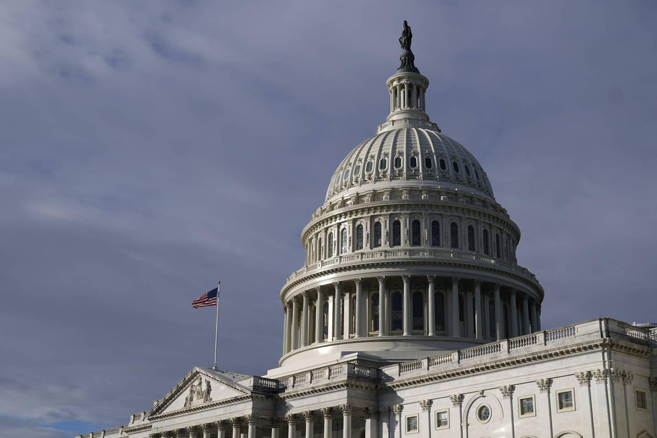
Sunlight shines on the U.S. Capitol dome, Wednesday, Oct. 27, 2021, on Capitol Hill in Washington. (Patrick Semansky / Associated Press)
Alaska’s nonprofit community heroically stepped up these last two years to serve Alaskans sickened, laid off and set back by the devastating effects of the pandemic.
Federal money has been critical to that response, allowing our organizations — Women in Safe Homes, First City Homeless Services, Nome Community Center, Covenant House Alaska and the Girdwood Health Clinic — to expand operations to meet historic demand.
Now, with federal pandemic relief winding down, Sen. Lisa Murkowski has stepped up and used the Congressionally Directed Spending process to ensure that we can make critical investments in our communities that will last long after the emergency has passed.
The overdue return of the Congressionally Directed Spending process means that Alaskans once again have a voice in how their hard-earned tax dollars are put to work in Alaska. From the smallest towns far from the road system to the biggest cities in Alaska, Sen. Murkowski championed more than $29 million for organizations connected to Alaskans through the 2-1-1 system.
Since the beginning of the pandemic, Alaska 2-1-1 has responded to 300% more calls than in 2019, connecting Alaskans to each of our organizations and many more. Through the Congressionally Directed Spending process, 2-1-1 will receive $1 million to allow United Way of Anchorage to expand Alaska 2-1-1′s service hours, texting capabilities and resource database to make sure that Alaskans get connected to the help they need, when they need it.
Congressionally Directed Spending may have once been derided as “earmarks” or “pork-barrel spending.” Today, these funds are anything but. These are local projects to address needs that we see every day in our communities, not one-size-fits-all projects implemented by a bureaucrat in Washington, D.C.
Many of these projects have been years in the making or have taken on renewed importance during the pandemic.
In fact, the work funded by this congressional spending is nothing short of transformational. Our organizations will use this money to construct facilities to support the homeless and survivors of domestic violence in Ketchikan. Housing and public health services will be provided to vulnerable people in Nome. Statewide, training will be provided by Covenant House Alaska to help address youth, child and family homelessness.
These investments will strengthen our organizations and the communities that we serve. By soliciting funding ideas directly from Alaskans, Sen. Murkowski has made sure that together we will emerge from this pandemic more resilient than ever. Thanks to Sen. Murkowski for making this congressional spending Alaska-directed.
Clark Halvorson is president and CEO of United Way of Anchorage. Agnes Moran is executive director of WISH. Rhonda Schneider is executive director of the Nome Community Center. Tawny Buck serves as executive director of Girdwood Health Clinic; Jessica Pilcher serves as vice-chair of First City Homeless Services. Alison Kear is executive director of Covenant House Alaska.

